AI Assignment

Assignment submitted to

Graduate School at

The University of Arkansas at Little Rock

in partial fulfillment of

requirements for the graduate course of

202510 Spring: Data Science - Technologies (9U1)

in

March 2025

by

Deepak Singla

Instructors

Dr. Elizabeth Pierce

and

Dr. Serhan Dagtas

ABSTRACT

This assignment covers three very important aspects of AI

Introduction to AI

AI Ethics

AI Concepts

These courses have been taken from CognitiveClass.ai. These completions of courses have been shown below by taking screenshots of the progress of the course. CognitiveClass.ai has not release the quiz in these courses yet so there won’t be any completion certificates.

User account in CognitiveClass.ai is *thejavascriptways*  as appears on top right corner of the images below.

Introducing AI

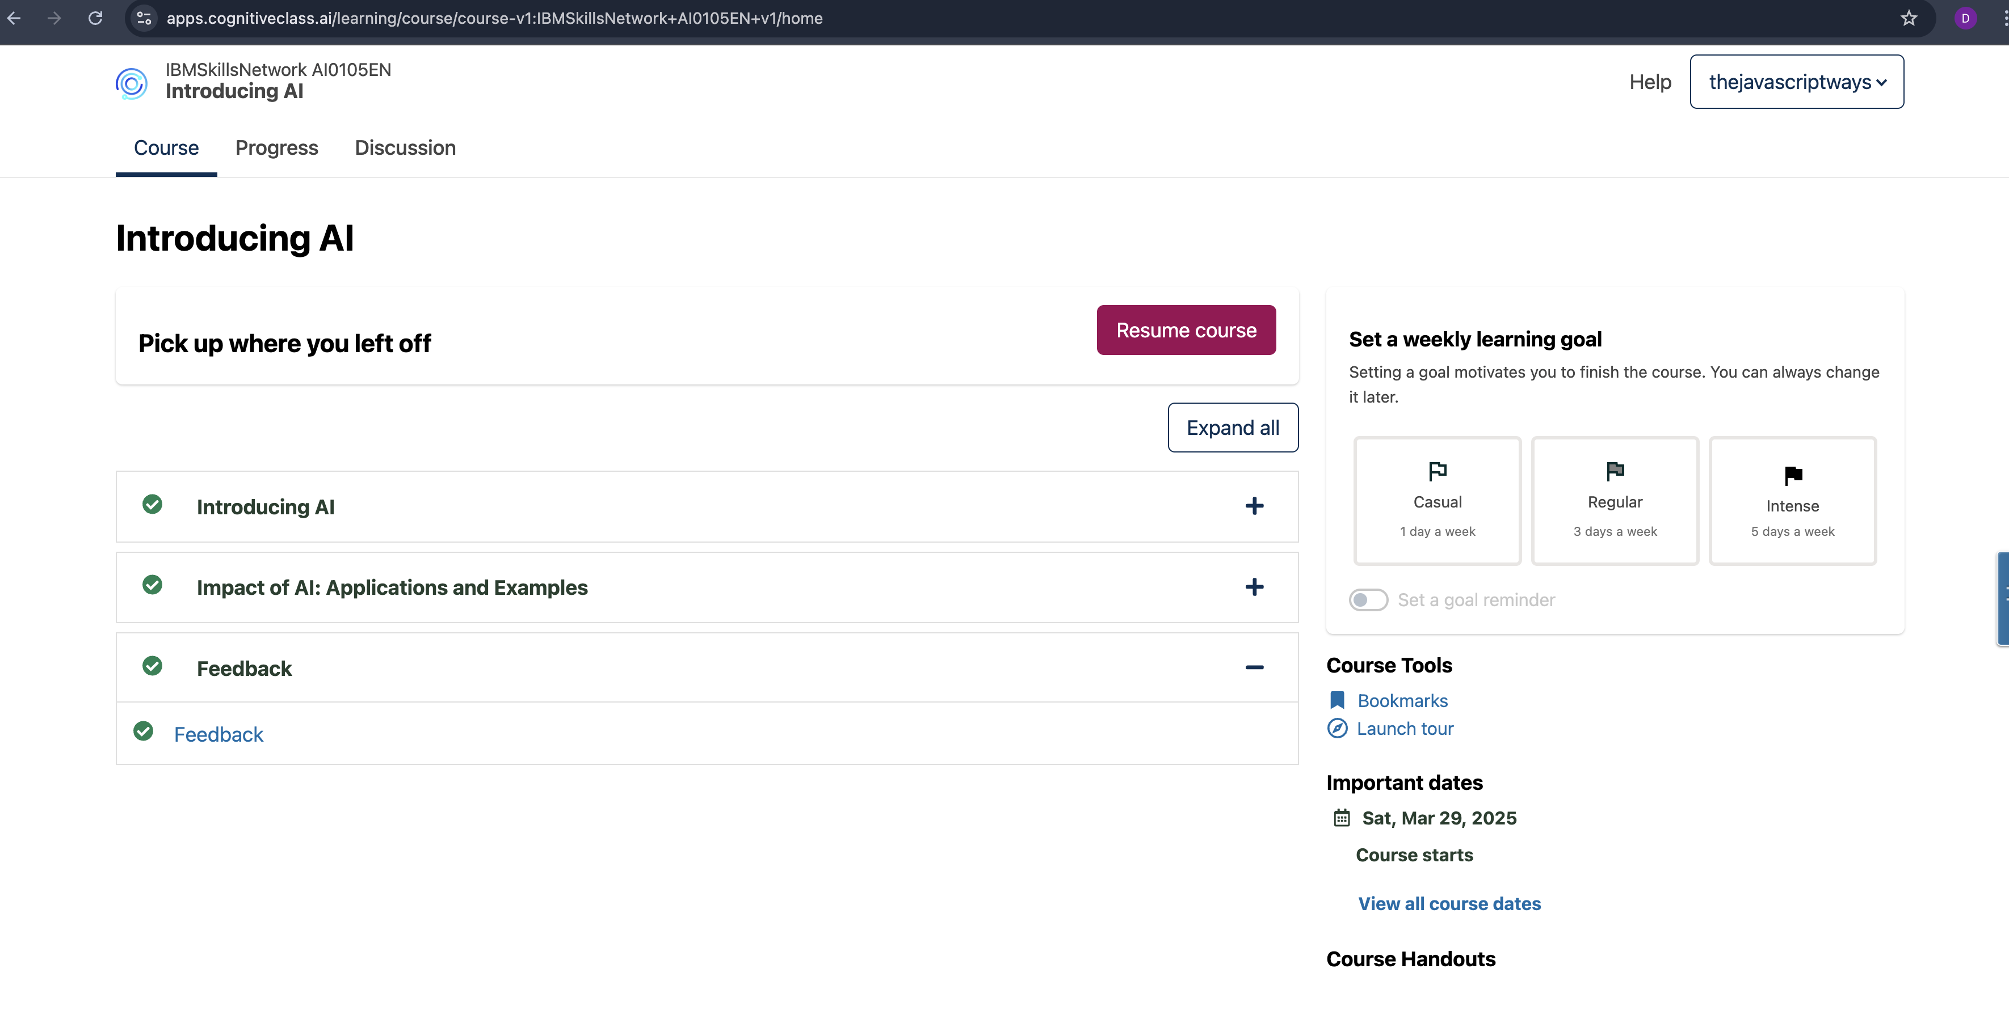

AI Ethics

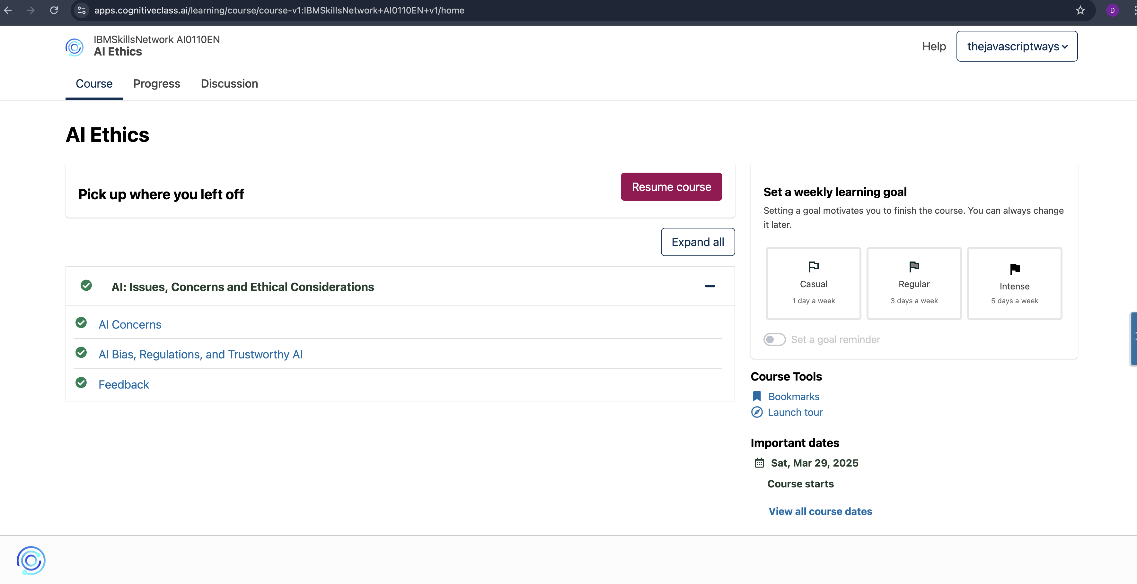

AI Concepts

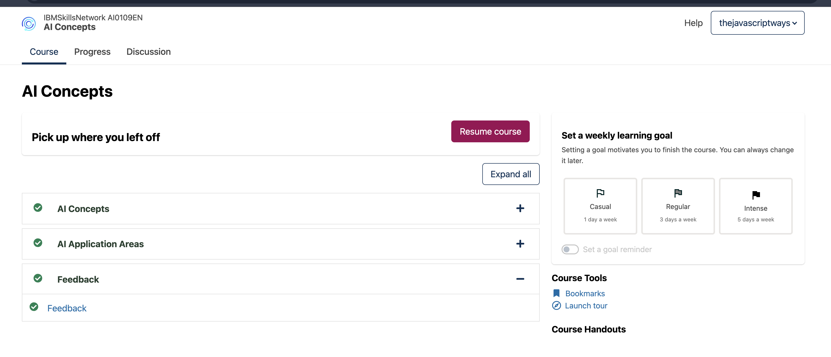

Credits

Report format has been copied from

<https://www.proquest.com/pqdtlocal1009983/docview/2902800999/fulltextPDF/C967C462E7DF4DF2PQ/1?%20Theses&accountid=14482&sourcetype=Dissertations%20>

Other References

<https://cognitiveclass.ai/courses>